**Business Question and Visualization Report**

|  |  |
| --- | --- |
| Date | 6 October 2025 |
| Team ID | xxxxxx |
| Project Name | Predicting Plant Growth Stages with Environmental and Management Data Using Power BI |
| Maximum Marks | 5 Marks |

Visualization development refers to the process of creating graphical representations of data to facilitate understanding, analysis, and decision-making. The goal is to transform complex datasets into visual formats that are easy to interpret, enabling users to gain insights and make informed decisions. Visualization development involves selecting appropriate visual elements, designing layouts, and using interactive features to enhance the user experience. This process is commonly associated with data visualization tools and platforms, and it plays a crucial role in business intelligence, analytics, and reporting

**Business Questions and Visualisation**

The process involves defining specific business questions to guide the creation of meaningful and actionable visualizations in Power BI. Well-framed questions help in identifying key metrics, selecting relevant data, and building visualisation that provide insights.

**1.What is the overall Growth Milestone success rate, and how does it compare across Soil Types?**

Clustered Bar Chart

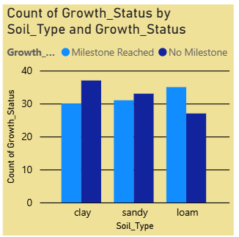

Displays the percentage of plants that reached the milestone vs. those that didn't, segmented by Soil_Type. This quickly identifies the **best and worst performing soil types**.

**2.Which specific care protocol (Water/Fertilizer) yields the highest success rate?**

**Matrix Table / Clustered Column Chart (using filters)**

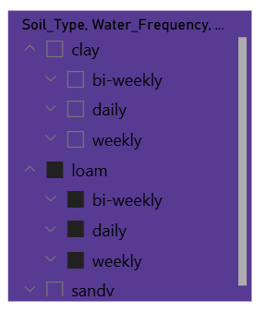

Shows the Success_Rate measure filtered by the unique combinations of Water_Frequency and Fertilizer_Type. This determines the Optimal Care Protocol**.**

**3.What is the ideal environmental window for successful growth?**

**Scatter Plot**

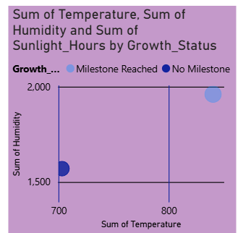

Plots Temperature on the X-axis and Humidity on the Y-axis, with points colored by the Growth_Status. This reveals the Optimal Environmental Cluster (Temp/Humidity "sweet spot").

**4.How does the count of successful vs. unsuccessful plants vary across different Temperature Bands (Low, Medium, High)?**

**Card Visual (KPI)**

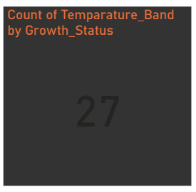

Compares the frequency (count) of success versus failure for plants in different temperature ranges. This requires creating a Temperature_Band column in Power Query**.**

**5.What is the average performance metric (e.g., Temperature) of *only* the successful plants?**

**Card Visual (KPI)**

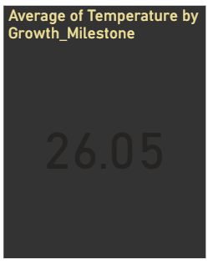

Displays the Average of Temperature measure, with a visual-level filter applied where Growth_Milestone = 1. This provides a precise target value for environmental controls**.**

**6.How much variance exists in Humidity across different Soil Types?**

Clustered Column Chart

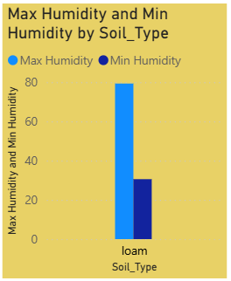

**This visual immediately shows which soil type is associated with the widest range (variance) in humidity, and whether the average humidity differs significantly between "clay," "sandy," and "loam"** soils.

**7. What percentage of plants are using Organic fertilizer compared to Chemical or None?**

**Pie Chart:**

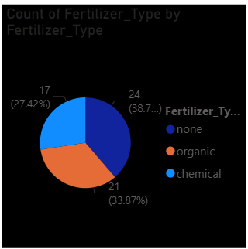

Shows the proportion of the total dataset by Fertilizer_Type. This provides context on resource usage or treatment prevalence in the study.

**8.What is the maximum and minimum Sunlight Hours observed for plants that achieved the milestone?**

**Multi-row Card** visual

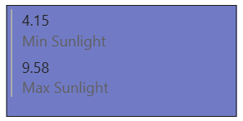

This provides the Grower with two precise, filterable numbers that define the boundary conditions for successful sunlight exposure.